**5. SYSTEM DESIGN**

1. **DATA DICTIONARY**

**Intern/Student Registration**

|  |  |  |  |  |
| --- | --- | --- | --- | --- |
| Field name | Type | Size | Key | Constraint |
| Id | Int | 10 | Primary key | Not null |
| Name | Varchar | 25 | **-** | Not null |
| Address | Varchar | 50 | **-** | Allow null |
| Email | Varchar | 20 | **-** | Not null |
| Contact | Int | 11 | **-** | Not null |
| birthdate | Varchar | 20 | **-** | Allow null |
| Password | Varchar | 10 | **-** | Not null |

**Faculty Registration**

|  |  |  |  |  |
| --- | --- | --- | --- | --- |
| Field name | Type | Size | Key | Constraint |
| Id | Int | 10 | Primary key | Not null |
| Name | Varchar | 25 | **-** | Not null |
| Experience | Varchar | 15 | **-** | Allow null |
| Address | Varchar | 50 | **-** | Allow null |
| Email | Varchar | 20 | **-** | Not null |
| Contact | Varchar | 11 | **-** | Not null |
| Expert in | Varchar | 20 | **-** | Allow null |
| Password | Varchar | 10 | **-** | Not Null |

**Login**

|  |  |  |  |  |
| --- | --- | --- | --- | --- |
| Field name | Type | Size | Key | Constraint |
| User name | Varchar | 20 | **-** | Not null |
| Password | Varchar | 10 | **-** | Not null |

**Student Request**

|  |  |  |  |  |
| --- | --- | --- | --- | --- |
| Field name | Type | Size | Key | Constraint |
| Std_id | Int | 10 | Foreign Key | Not null |
| name | Varchar | 20 | **-** | Not null |
| Add faculty | Varchar | 20 | **-** | Allow null |

**Grant Leave**

|  |  |  |  |  |
| --- | --- | --- | --- | --- |
| Field name | Type | Size | Key | Constraint |
| Std _id | Int | 10 | Foreign Key | Not null |
| Std_name | Varchar | 20 | **-** | Not null |
| Fac_name | Varchar | 20 | **-** | Allow null |
| Course | Varchar | 20 | **-** | Allow null |
| reason | Varchar | 20 | **-** | Allow null |

**Leave**

|  |  |  |  |  |
| --- | --- | --- | --- | --- |
| Field name | Type | Size | Key | Constraint |
| Std _id | Int | 10 | Foreign Key | Not null |
| Std_name | Varchar | 20 | **-** | Not null |
| Course | Varchar | 20 | **-** | Allow null |
| reason | Varchar | 20 | **-** | Allow null |

**Add Courses**

|  |  |  |  |  |
| --- | --- | --- | --- | --- |
| Field name | Type | Size | Key | Constraint |
| Crse_id | Int | 10 | Primary Key | Not null |
| Crse_name | Varchar | 20 | **-** | Not null |
| Ass_Fac | Varchar | 20 | Foriegn Key | Allow null |

* 1. **SCREEN LAYOUT**
* Interns Side Form Layouts:

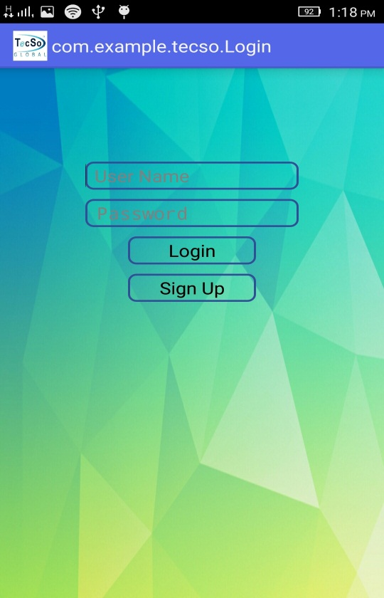

Fig: 5.2.1 Login Page

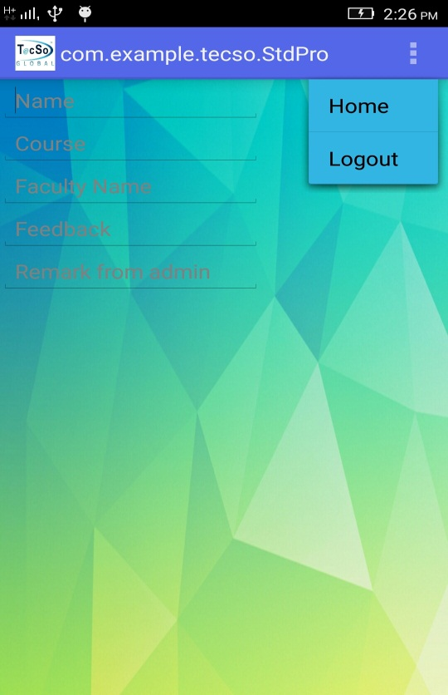

Fig: 5.2.2 Interns Profile Page

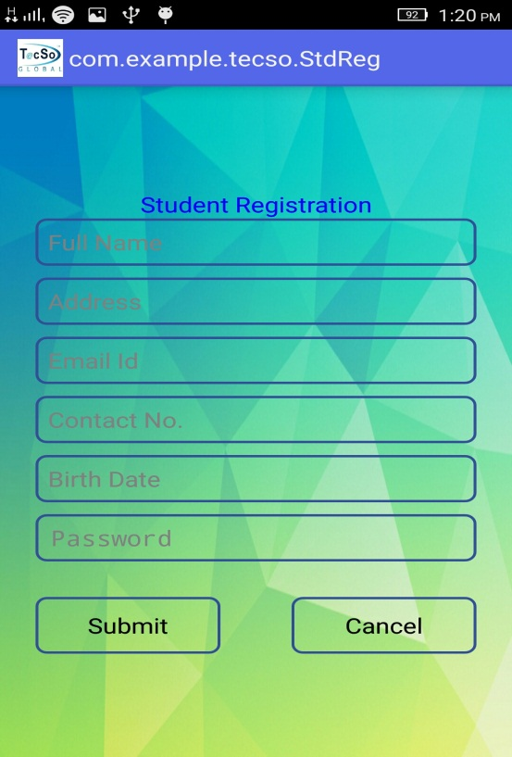

Fig: 5.2.3 Registration Form

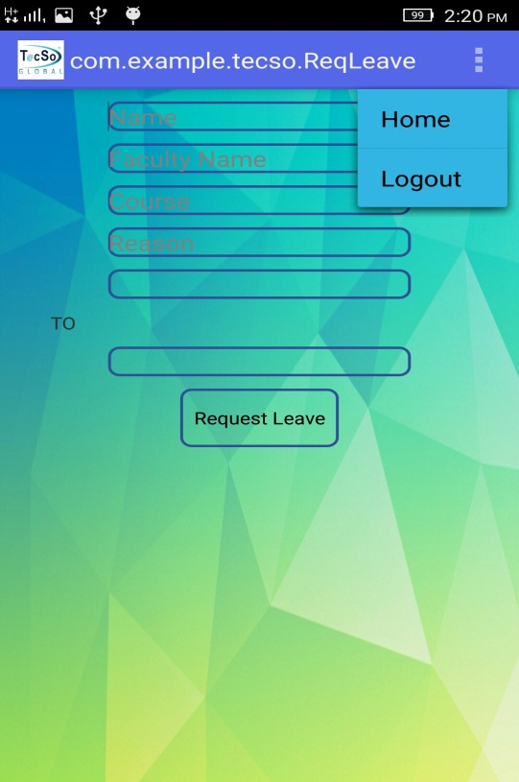

Fig: 5.2.4 Leave Request Form



Fig: 5.2.5 Intern Home Page

* Admin Side Form Layouts:

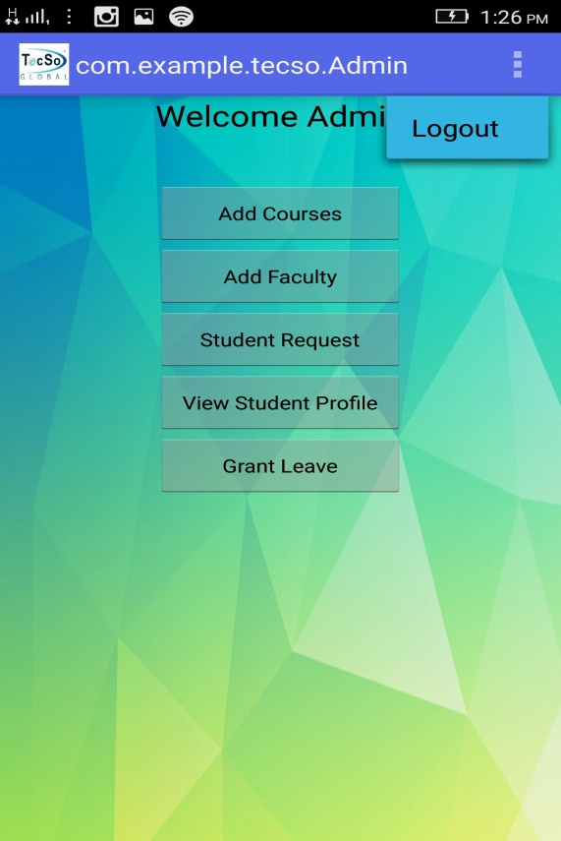

Fig: 5.2.6 Admin Page

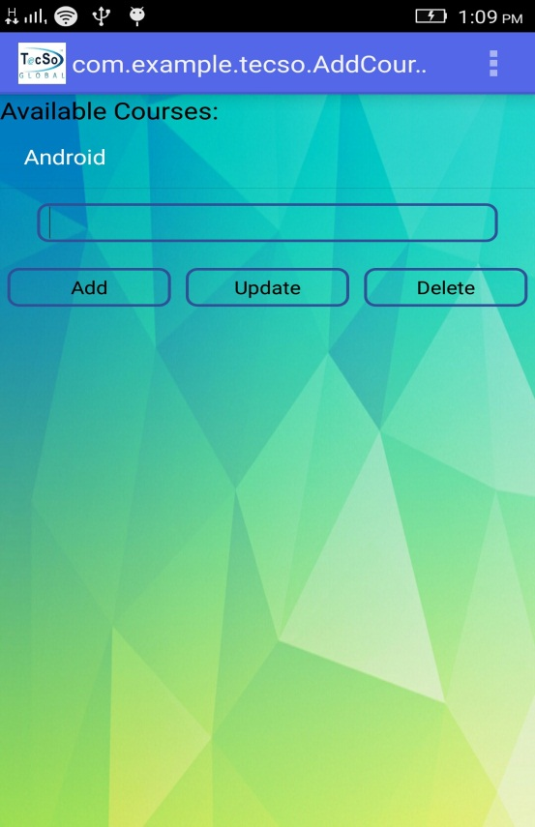

Fig: 5.2.7 Available Courses

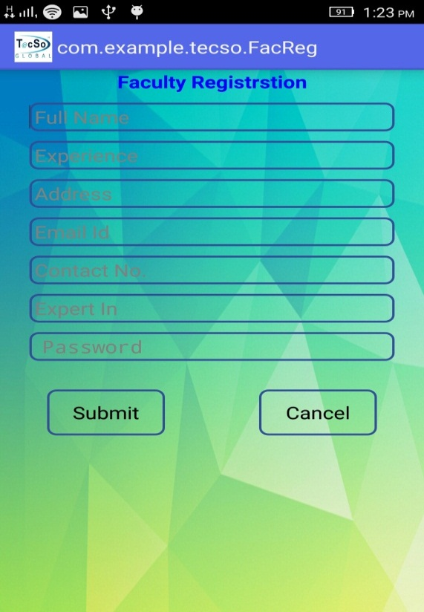

Fig: 5.2.8 Faculty Registration Form

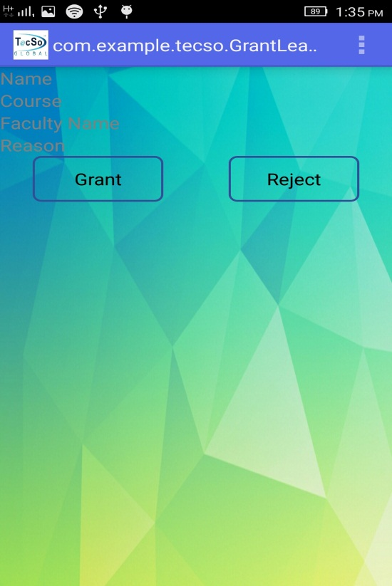

Fig: 5.2.9 Leave Permission Form



Fig: 5.2.10 Assign Faculty to Intern



Fig: 5.2.11 View Intern Profile



Fig: 5.2.12 Intern Profile Page for Admin